When Occupancy Aging Changes a CVaR Energy–Reserve Bid: A SMARD Diagnostic
Amir Hassanli and Ali Reza Abbasi
Abstract—This paper develops and evaluates a diagnostic framework for determining when explicit calendar-aging exposure can change a stationary battery energy storage system (BESS) bidding decision relative to a cycle-centric degradation model. A price-taking virtual power plant (VPP) comprising a 2.5 MW/5 MWh BESS is formulated as a single linear mean–CVaR day-ahead energy and reserve optimization problem. Three interchangeable aging representations are evaluated under identical plant, market, and uncertainty conditions: a throughput cost, a piecewise-linear daily depth-of-discharge (DoD) model, and the proposed Reserve-aware Layered Calendar–Cycle Aging (ReLCCA) formulation. ReLCCA represents state-of-charge (SoC) occupancy and band flow explicitly, thereby assigning a calendar-aging cost to energy parked to support upward reserve. The formulation preserves linearity through band decomposition, piecewise-linear epigraphs, and the standard Rockafellar–Uryasev CVaR representation. Public German DE-LU market and physical series are used for a 262-day study window. The empirical analysis is deliberately diagnostic rather than a claim of universal dominance. On ordinary isolation days, the three aging laws produce closely aligned reserve-versus-energy rankings. On 1 May 2026, however, the throughput energy-only solution becomes long during a −499 EUR/MWh midday trough, whereas ReLCCA remains short. Wholesale decomposition shows that the resulting 1,312 EUR difference is dominated by the day-ahead energy position (1,246 EUR), while the direct aging-cost difference is only 54 EUR. A controlled trough-injection experiment and a 20-day negative-price scan further show that the mechanism is conditional on the residual portfolio state, not negative prices alone. The study therefore contributes a reproducible diagnostic procedure for identifying when calendar-aware BESS degradation can alter market positioning in a risk-aware VPP model.
Index Terms—Virtual power plant, battery energy storage, battery degradation, calendar aging, cycle-depth cost, CVaR, aFRR, SMARD, linear programming.
I. INTRODUCTION
Virtual power plants (VPPs) aggregate distributed energy resources into a coordinated market-facing portfolio, enabling heterogeneous assets to provide energy and ancillary services as a controllable unit [1], [2]. The economic value of such portfolios is strongly affected by uncertainty in renewable production and electricity prices, which has motivated stochastic, robust, and risk-aware bidding formulations [3]–[9]. In these models, stationary battery energy storage systems (BESSs) provide temporal flexibility and reserve capability, but their value cannot be assessed independently of the degradation caused by operation and by time spent at particular states of charge (SoC).
The battery-degradation literature distinguishes cycle aging from calendar aging. Established experimental and semi-empirical studies show that capacity loss depends on factors including depth of discharge, SoC, temperature, time, and electrochemical state [20]–[25]. Market-oriented formulations have consequently moved from simple throughput penalties toward cycle-depth functions and degradation-aware dispatch [17], [18], [26]–[29]. Nevertheless, the market optimization literature often represents degradation as a cost of charging/discharging or cycle depth. Such representations can price energy throughput while leaving the economic exposure of energy deliberately held in the battery insufficiently explicit.
This issue matters when BESS capacity is simultaneously used for energy arbitrage and reserve. Upward reserve requires energy headroom and therefore constrains the SoC region in which the battery must remain. If calendar aging depends on SoC, then the energy parked to preserve reserve availability has an opportunity cost that is not equivalent to a pure throughput charge. Existing work on energy–reserve co-optimization, battery degradation, and probabilistic reserve delivery provides important building blocks [18], [19], [30]–[33], but the interaction between SoC occupancy, reserve parking, and calendar aging remains comparatively underexplored in a transparent linear market model.
This paper addresses that issue with a deliberately narrow research question: under what residual-load and price conditions does explicitly pricing SoC occupancy change the optimal mean–CVaR energy–reserve bid relative to a cycle-depth representation? The objective is not to establish that one degradation model dominates another under all conditions. Instead, the study constructs a controlled diagnostic in which the plant, uncertainty treatment, solver, and market assumptions remain fixed while only the aging representation changes.
The main contributions are fourfold. First, a unified linear formulation permits three aging laws to be swapped without changing the remaining market model. Second, ReLCCA combines a calendar-aging occupancy term and a cycle-aging band-flow term and couples upward reserve to stored-energy parking. Third, a wholesale decomposition separates the direct aging-cost difference from changes in the optimized day-ahead energy position. Fourth, a controlled negative-price injection and an exhaustive scan of all qualifying days in the study window identify whether the observed ranking reversal is a generic price effect or a conditional portfolio-state effect.
The remainder of the paper is organized as follows. Section II reviews VPP bidding, battery-aging, risk, and reserve-market literature. Section III defines the system, data, and information structure. Section IV presents the complete linear mathematical formulation. Section V describes the experimental design. Section VI reports the results. Section VII discusses the mechanism and robustness. Section VIII states limitations, and Section IX concludes.
II. RELATED WORK AND RESEARCH GAP
The literature review was constructed from the supplied Literature Review document and the manuscript reference base, with emphasis on studies directly relevant to the intersection of VPP market participation, BESS degradation, uncertainty, risk, and reserve services. General VPP surveys establish the role of aggregation and market participation [1], [10], [11]. More recent work has expanded the scope toward uncertainty-aware dispatch, joint energy–reserve scheduling, and risk-averse VPP operation [9], [30]–[34].
For market scheduling, stochastic and robust optimization are well established. Krishnamurthy et al. model storage arbitrage under day-ahead and real-time price uncertainty [19], while Baringo and Rahimiyan and Baringo and Baringo develop robust and adaptive-robust VPP offering formulations [7], [8]. Vahedipour-Dahraie et al. explicitly combine energy and reserve scheduling with demand response under risk aversion [9]. More recent studies extend this direction to distributionally robust VPP bidding [34], [35] and risk-averse energy–frequency regulation scheduling [36]. These studies demonstrate the importance of uncertainty treatment but do not resolve how calendar-aging exposure from reserve parking should be represented in a linear market model.
Battery-aging research provides the second foundation. Vetter et al. and Broussely et al. distinguish the major electrochemical aging mechanisms [20], [21], while Barré et al. review the dependence of aging on operating conditions [22]. Keil et al. demonstrate the importance of SoC for calendar aging [23], and Schmalstieg et al. provide a holistic semi-empirical NMC aging model combining calendar and cycle effects [24]. Ecker et al. provide experimental evidence for calendar and cycle life of NMC cells [25]. Naumann et al. provide complementary evidence for calendar aging of commercial LFP/graphite cells [37].
Optimization-oriented degradation models seek computational tractability. Hesse et al. formulate age- and efficiency-aware battery dispatch with MILP [17]. Xu et al. introduce cycle-aging cost functions suitable for electricity-market optimization [26], [27], and Shi et al. establish convexity properties of cycle-aging costs under rainflow-based formulations [28]. Collath et al. review aging-aware operation and subsequently demonstrate lifetime-profitability improvements from including calendar and cycle aging in optimization [18], [38]. Petrin et al. study convex-hull representations of battery aging and quantify the accuracy–computational-cost trade-off [39]. Kumtepeli et al. integrate electro-thermal and semi-empirical aging models into an optimization framework [40].
For ancillary services, He et al. incorporate performance-based regulation and cycle life into battery bidding [18], while Akhavan-Hejazi and Mohsenian-Rad study joint energy and reserve operation of storage under high wind penetration [29]. Toubeau et al. impose probabilistic guarantees on real-time reserve delivery [30]. Merten et al. study battery bidding in the German secondary control reserve market and the prediction of aFRR market variables [31], [32]. Fernández-Muñoz and Pérez-Díaz develop stochastic scheduling and redispatch models for a wind–battery VPP participating in day-ahead and secondary regulation markets, including degradation and storage opportunity cost [33], [41]. Ghanaee et al. more recently include both calendar and cycle degradation in day-ahead and reserve scheduling of a hybrid wind–battery plant [42].
Risk management is the third strand. Coherent risk measures were formalized by Artzner et al. [13], and the Rockafellar–Uryasev representation makes CVaR tractable within linear optimization [14], [15]. Recent VPP studies continue to use CVaR for energy and ancillary-service bidding [36], [43]. Onsomu et al. demonstrate uncertainty-aware VPP dispatch using CVaR-related formulations [44], while Wang et al. develop a CVaR-based energy and frequency-regulation bidding framework for PV-storage systems [43].
The literature therefore contains strong and complementary solutions to VPP aggregation, stochastic bidding, risk management, cycle-aging valuation, and reserve participation. The unresolved issue targeted here is narrower: a transparent linear formulation in which (i) calendar aging is linked to SoC occupancy, (ii) cycle aging remains explicitly represented, (iii) upward reserve is coupled to the energy parked in the battery, (iv) mean–CVaR bidding is retained, and (v) the mechanism is diagnosed on public German market data without claiming that proxy reserve or imbalance series are equivalent to day-specific cleared settlement tapes. The present study addresses this gap as a diagnostic rather than as a universal degradation-model validation.
TABLE I. POSITION OF THE PRESENT STUDY RELATIVE TO SELECTED LITERATURE
Study | VPP / storage | Degradation | Risk / uncertainty | Energy–reserve | Main relevance
Hesse et al. [17] | BESS | Ageing + efficiency | Deterministic | Energy arbitrage | MILP degradation-aware dispatch
Xu et al. [26], [27] | BESS | Cycle depth | Market uncertainty | Energy/reserve | Cycle-aging cost formulation
Collath et al. [18], [38] | BESS | Calendar + cycle | Operational scenarios | Energy services | Aging-aware profitability
Toubeau et al. [30] | Storage | — | Probabilistic delivery | Energy/reserve | Reserve feasibility
Merten et al. [31], [32] | BESS | Aging considered | Market forecasting | aFRR | German reserve participation
Fernández-Muñoz & Pérez-Díaz [33] | Wind–BESS VPP | DoD/rate | Stochastic | DA + secondary reserve | VPP scheduling
Ghanaee et al. [42] | Wind–BESS | Calendar + cycle | Deterministic | DA + reserve | Recent degradation-aware benchmark
Wang et al. [43] | PVSS | Operational constraints | CVaR | Energy + regulation | Recent risk-aware benchmark
This work | VPP + BESS | Calendar occupancy + cycle | Mean–CVaR | DA + aFRR capacity | Diagnostic of occupancy-driven bid changes
Table I is intended to prevent an overstatement of novelty. The contribution is not the first use of degradation, CVaR, stochastic bidding, or reserve participation individually. Rather, it is the controlled diagnostic that isolates the incremental market-position effect of making calendar occupancy explicit while keeping the rest of the linear bidding architecture fixed.
III. SYSTEM, DATA, AND INFORMATION STRUCTURE
A. VPP Configuration and Market Role
The VPP is modeled as a price-taker in the German DE-LU bidding area. The portfolio contains a 5 MW-class industrial load, 4 MW PV, 2 MW wind, a 2.5 MW/5 MWh stationary BESS, and a 1.8 MW dispatchable generator. The battery uses ηc = ηd = 0.95, a 10–90% SoC range, and cyclic operation over each daily horizon. The DG marginal operating cost is 68 EUR/MWh and its ramp limit is 1.2 MW/h. The default upward/downward reserve cap is 1.5 MW. These values are the fixed study configuration and are not fitted to the observed results.
TABLE II. PLANT, MARKET, AND COMPUTATIONAL PARAMETERS
Parameter | Value | Role / source
BESS power / energy | 2.50 MW / 5.00 MWh | Study plant
PV / wind / load class | 4 / 2 / 5 MW | Study plant
ηc / ηd | 0.95 / 0.95 | BESS round-trip = 0.9025
SoC range | 10–90% | Operational constraint
DG capacity / cost | 1.8 MW / 68 EUR/MWh | Dispatchable recourse
DG ramp | 1.2 MW/h | Operational constraint
Reserve cap | 1.5 MW | Default sensitivity parameter
CVaR α | 0.95 | Tail confidence
CVaR weight β | 0.05 | Risk weight
Default bands N | 8 | ReLCCA discretization
Solver | HiGHS | Open-source LP solver
Random seed | 20260821 | Reproducibility
Table II separates physical assumptions from market-data proxies. In particular, reserve capacity prices are not day-specific auction tapes. The study uses published German aFRR four-hour block means for 2025–mid-2026 and applies the same six-block schedule to each operating day. Similarly, the imbalance price is represented by a documented two-price proxy because a directly mounted reBAP series was not available in the study package. These choices are retained explicitly to avoid presenting proxy values as observed settlements.
B. Public Data and Scaling
The empirical panel covers 1 December 2025 00:00 through 21 August 2026 07:00 Berlin time, yielding 6,319 hourly observations and 262 complete days. Public German market and physical series are obtained from Bundesnetzagentur SMARD through the Fraunhofer ISE Energy-Charts interface [45], [46]. The panel contains 403 negative-price hours. National physical series are scaled using the frozen Gate-10 factors so that the study-window 95th-percentile load is 5 MW and the window maxima of solar and wind correspond to 4 MW and 2 MW, respectively. The factors are not re-estimated on individual days.
The information structure distinguishes first-stage market positions from scenario-dependent operating recourse. For each day, day-ahead energy and reserve positions are common across scenarios, while charging, discharging, DG output, imbalance, and band-level operating variables respond to the realized scenario. Scenario probabilities are uniform within the daily scenario set.
C. Reserve and Imbalance Proxies
For each four-hour block, the reserve capacity prices are the published German aFRR block means used in the study. Positive-direction block means are 4.5, 12.0, 47.1, 18.4, 35.6, and 8.0 EUR/MW/h; negative-direction means are 6.0, 15.0, 36.9, 57.4, 20.0, and 2.4 EUR/MW/h [47], [48]. These values are held fixed across days. The imbalance proxy is defined by the day-ahead price λtDA: short deviations are settled at λtDA + 18 + 0.12|λtDA|, while long deviations are settled at λtDA − 10 − 0.08|λtDA|, with the additional bounds that the short price is at least λtDA + 5 and the long price is at most λtDA − 3. The 150 EUR/MWh clipping case is treated only as a robustness test.
IV. MATHEMATICAL FORMULATION
The three aging laws are embedded in the same daily linear market model. This separation is important: all non-aging constraints, market prices, scenario inputs, and risk parameters are unchanged when the aging law is replaced. The resulting optimization is a linear program (LP). No binary charging/discharging variable is required in the implemented formulation; simultaneous charge/discharge is prevented by the economic structure and the reported parameterization rather than by a binary mode constraint.
A. Sets, Indices, and Parameters
Symbol | Definition | Unit | Type
t | Hourly time index | h | Index
ω | Scenario index | – | Index
ℓ | SoC-band index | – | Index
T | Number of hours in daily horizon | h | Parameter
K | Number of scenarios | – | Parameter
N | Number of SoC bands | – | Parameter
πω | Scenario probability | – | Parameter
Δt | Time-step length | h | Parameter
Emax, Emin | BESS energy limits | MWh | Parameter
P̄B | BESS power rating | MW | Parameter
ηc, ηd | Charge/discharge efficiency | – | Parameter
λtDA | Day-ahead energy price | EUR/MWh | Parameter
ρt↑, ρt↓ | Up/down reserve capacity price | EUR/MW/h | Parameter
L tω | Load | MW | Parameter
W tω, PV tω | Wind and PV availability | MW | Parameter
cDG | DG marginal cost | EUR/MWh | Parameter
R̄ | Reserve capacity limit | MW | Parameter
α | CVaR confidence level | – | Parameter
β | CVaR weight | – | Parameter
κℓ | Calendar-aging coefficient of band ℓ | EUR/MWh/h | Parameter
γℓch, γℓdis | Cycle-aging coefficients | EUR/MWh | Parameter
ΔEℓ | Energy width of band ℓ | MWh | Parameter
B. Decision Variables
Variable | Definition | Unit | Stage
p tDA | Day-ahead energy position | MW | First
r t↑, r t↓ | Upward/downward reserve capacity | MW | First
p tωch, p tωdis | BESS charge/discharge power | MW | Recourse
E tω | BESS stored energy | MWh | Recourse
g tω | DG output | MW | Recourse
z tω | Net imbalance/deviation | MW | Recourse
u tωℓ | Fractional occupancy of SoC band ℓ | – | Recourse
p tωℓch, p tωℓdis | Band-level charge/discharge flow | MW | Recourse
ζ | CVaR threshold variable | EUR | Master
sω | CVaR scenario shortfall auxiliary variable | EUR | Recourse
C. Scenario Power Balance

THREE AGING LAWS
Throughput attaches 1.5 EUR/MWh to charge and to discharge. Xu daily depth is dω = (maxt Et,ω − mint Et,ω)/Eb, written as a convex PWL with widths (0.20, 0.30, 0.30, 0.20) and slopes (10, 40, 80, 120) EUR per unit depth [26]. A full nameplate swing costs 62 EUR before throughput.
ReLCCA partitions [Emin, Emax] into N bands of equal width. Fill fractions obey ut,ω,ℓ ≤ ut,ω,ℓ−1. Calendar and cycle costs are defined as:
C_cal_omega = Σ_t,ℓ (κ_ℓ * ΔE_ℓ * u_t,ω,ℓ), C_cyc_omega = Σ_t,ℓ (γ_ℓ_ch * p_t,ω,ℓ_ch + γ_ℓ_dis * p_t,ω,ℓ_dis) (1)
Upward reserve occupies those bands according to the parking rule:
r_t^↑ * Δt / η_d ≤ Σ_ℓ (u_t,ω,ℓ * ΔE_ℓ) (2)
Equation (1) is already combined calendar-plus-cycle cost. Constraint (2) prices parking, not activated reserve energy. The default band count is N = 8; N ∈ {4, 6, 8, 12} is solved on 1 May.
Calendar coefficients come from three published Keil NMC 25 °C ten-month plateaus [23]: 1.2% fade at low SoC, 2.4% at mid SoC, 4.0% at high SoC. Linear 12/10 annualisation times 150 000 EUR/MWh replacement converts those three numbers into κ ∈ {0.247, 0.493, 0.822} EUR/MWh/h. The eight bands of the default map are a step assignment of those three values (low, low, mid, mid, mid, high, high, high). A quadratic through the eight assigned centres has R² = 0.89; that figure is a smoother of a three-level step, not a statistical fit on independent cells, and is not used as evidence. Uncertainty is reported by re-solving 1 May with all-mid κ, all-high κ, and a 5.5% top-band (Keil at 100% SoC). Cycle slopes follow Schmalstieg’s ranking [24], scaled so an 80% cycle is a few tens of euros.

Power balance, DG ramps and inverter headroom are the Gate-10 constraints. Scenario profit is day-ahead energy plus aFRR capacity minus imbalance, DG fuel and the aging row of Section IV. The risk-averse optimization objective is formulated as:
max (1−β) * Σ_ω (π_ω * Π_ω) + β * CVaR_α(Π) (3)
For every hour and scenario, the portfolio must balance physical load, scheduled market position, renewable generation, DG output, and battery exchange. With positive z representing a net deviation that is settled in the imbalance market, the balance is:
(4) pDA_t + g_tω + PV_tω + W_tω + pdis_tω − pch_tω + z_tω = L_tω, ∀t,ω.
Equation (4) is linear because every term is a scalar power variable or an exogenous parameter. The equation is the physical coupling between the first-stage day-ahead position and scenario-dependent real-time operation.
D. Renewable and DG Constraints
(5) 0 ≤ PV_tω ≤ PV̄_tω, 0 ≤ W_tω ≤ W̄_tω, ∀t,ω.
(6) 0 ≤ g_tω ≤ P̄DG, ∀t,ω.
(7) −R↓DG ≤ g_tω − g_(t−1)ω ≤ R↑DG, ∀t>0,ω.
The renewable limits are linear availability constraints. The DG ramp constraint is also linear and avoids any nonlinear unit-commitment representation.
E. BESS Energy and Power Constraints
(8) 0 ≤ pch_tω ≤ P̄B, 0 ≤ pdis_tω ≤ P̄B, ∀t,ω.
(9) E_tω = E_(t−1)ω + ηc pch_tω Δt − (pdis_tω Δt)/ηd, ∀t,ω.
(10) Emin ≤ E_tω ≤ Emax, ∀t,ω.
(11) E_0ω = E_Tω, ∀ω.
Equation (9) is linear because ηc, ηd, and Δt are fixed parameters. Equation (11) implements the cyclic daily boundary condition used in the study. The reported 10–90% SoC range is imposed through Emin = 0.1Emax and Emax,oper = 0.9Emax when the normalized SoC representation is used.
F. Reserve Feasibility and Parking
The reserve variables are first-stage commitments. They are limited by the battery power capability and by the energy that must remain available for upward deployment.
(12) 0 ≤ r_t↑ ≤ R̄, 0 ≤ r_t↓ ≤ R̄, ∀t.
(13) pdis_tω + r_t↑ ≤ P̄B, ∀t,ω.
(14) pch_tω + r_t↓ ≤ P̄B, ∀t,ω.
(15) r_t↑ Δt / ηd ≤ Σℓ ΔEℓ u_tωℓ, ∀t,ω.
Equation (15) is the reserve-parking constraint. It is linear because reserve capacity and occupancy are multiplied only by fixed parameters. Importantly, it prices the energy held to support upward reserve but does not claim to model the detailed energy of an activated aFRR signal. This distinction is central to the interpretation of the results.
G. SoC-Band Decomposition
For ReLCCA, the usable battery-energy interval [Emin,Emax] is divided into N equal-width bands. The occupancy variables satisfy:
(16) 0 ≤ u_tωℓ ≤ 1, ∀t,ω,ℓ.
(17) u_tωℓ ≤ u_tω,ℓ−1, ∀t,ω,ℓ>1.
(18) E_tω = Emin + Σℓ ΔEℓ u_tωℓ, ∀t,ω.
The monotonicity condition in (17) produces a cumulative-fill representation. Band-level flows are linked to occupancy changes through:
(19) ΔEℓ(u_tωℓ − u_(t−1)ωℓ) = ηc p_tωℓch Δt − p_tωℓdis Δt/ηd, ∀t,ω,ℓ.
(20) Σℓ p_tωℓch = p_tωch, Σℓ p_tωℓdis = p_tωdis, ∀t,ω.
Equations (16)–(20) are a linear discretization of the continuous SoC trajectory. The model does not claim that eight bands reproduce electrochemical aging exactly; N is a numerical resolution parameter and is therefore tested explicitly.
H. Throughput Aging Law
The throughput benchmark assigns a constant marginal aging cost to battery energy processed in either direction:
(21) Cωthr = Σt cthr (pch_tω + pdis_tω) Δt.
The source model uses cthr = 1.5 EUR/MWh. This formulation is linear but does not distinguish depth of discharge or calendar exposure. Idle energy is therefore unpriced by the aging term.
I. Xu Daily Cycle-Depth Law
The Xu benchmark represents daily depth as the range of stored energy normalized by battery capacity:
(22) dω ≥ (E_tω − E_kω)/Emax, ∀t,k,ω.
(23) dω ≥ (E_kω − E_tω)/Emax, ∀t,k,ω.
The absolute range is represented by the pair of linear inequalities (22)–(23). The daily depth cost is then approximated by a convex piecewise-linear function with break-widths 0.20, 0.30, 0.30, and 0.20 and slopes 10, 40, 80, and 120 EUR per unit depth [26]. Introducing nonnegative segment variables qωj gives:
(24) dω = Σj qωj, 0 ≤ qωj ≤ wj, CωXu = Σj mj qωj.
This is an epigraph/segment formulation of the convex piecewise-linear cost. No nonlinear product is introduced.
J. ReLCCA Calendar and Cycle Aging
ReLCCA adds an explicit cost to SoC occupancy and a separate cost to band-level energy flow:
(25) Cωcal = Σt Σℓ κℓ ΔEℓ u_tωℓ Δt.
(26) Cωcyc = Σt Σℓ (γℓch p_tωℓch + γℓdis p_tωℓdis) Δt.
(27) CωReLCCA = Cωcal + Cωcyc.
Equation (25) is the defining calendar-occupancy term. A battery that remains parked at a high-SoC band incurs a calendar-aging cost even if no charge/discharge energy is processed during that hour. Equation (26) retains a cycle-related cost based on band flow. Both equations are linear because κ, γ, ΔE, and Δt are fixed coefficients.
The default N = 8 bands use a three-plateau κ map derived from the supplied Keil-based calibration: low-SoC bands use 0.247 EUR/MWh/h, mid-SoC bands 0.493 EUR/MWh/h, and high-SoC bands 0.822 EUR/MWh/h. The values are a linear annualized conversion of the study's 10-month plateau assumptions and are not a new electrochemical fit. The model therefore treats the κ map as a scenario parameter rather than a statistically estimated cell-aging law.
TABLE III. AGING-LAW FORMULATION AND ECONOMIC INTERPRETATION
Law | Direct cost | Idle energy | Reserve linkage | Linearization
Throughput | cthr × charge/discharge | Unpriced | Power headroom | None
Xu PWL | Convex daily SoC depth | Unpriced unless depth changes | Indirect through depth | Segment variables
ReLCCA | Calendar occupancy + band flow | Priced hourly | Upward reserve parking | Band decomposition
Table III clarifies the source of the diagnostic difference. Throughput and Xu primarily respond to energy processed or SoC swing. ReLCCA additionally assigns an economic cost to where the battery remains in the SoC range and therefore to energy deliberately retained for reserve feasibility.
K. Scenario Profit and Mean–CVaR Objective
For each scenario, wholesale profit is defined as:
(28) Πω = Σt [λtDA pDA_t + ρt↑ r_t↑ + ρt↓ r_t↓ − λt,ωimb z_tω − cDG g_tω] Δt − Cωage.
The retail load-service overlay used for reporting is not included in the optimization and is added after the wholesale solve. This prevents the overlay from changing the ranking of the market decisions.
The risk objective is:
(29) max (1−β) Σω πω Πω + β CVaRα(Π).
Because the implementation maximizes profit, the lower-tail CVaR is represented through the Rockafellar–Uryasev auxiliary formulation. Define loss Lω = −Πω. Then:
(30) CVaRα(L) = ζ + 1/(1−α) Σω πω sω.
(31) sω ≥ Lω − ζ, sω ≥ 0, ∀ω.
Substitution of Lω = −Πω into (30)–(31) yields a linear optimization model. The reported β = 0.05 and α = 0.95 therefore introduce tail sensitivity without requiring a nonlinear risk constraint.
L. Complete LP Statement
The implemented problem can be summarized as:
(32) max (1−β) Σω πω Πω − β[ζ + 1/(1−α) Σω πω sω]
subject to (4)–(24) and the selected aging-law equations (21), (24), or (25)–(27), together with (30)–(31), variable bounds, and the common market parameters. The first-stage variables pDA, r↑, and r↓ are scenario-independent; recourse variables are scenario-dependent. Every term in (32) is affine in the decision variables. Consequently, the final optimization is an LP.
No Big-M, McCormick envelope, SOS constraint, or KKT reformulation is required in the implemented model. Piecewise linearization is required only for the Xu depth cost and the band representation of ReLCCA; CVaR is linearized with auxiliary variables. This explicit accounting of linearization is important because it distinguishes the present model from nonlinear bi-level formulations that require KKT or strong-duality transformations.
V. EXPERIMENTAL DESIGN AND DIAGNOSTIC PROTOCOL
The evaluation uses four steps. Step 1 establishes ordinary-day agreement by solving all three aging laws on winter, spring, and summer isolation days and on two rolling weeks. Step 2 freezes the 19 August residual and replaces hours 9–16 with scaled copies of the 1 May trough, with the minimum varied from −50 to −499 EUR/MWh. Step 3 decomposes wholesale profit on any day where the model ranking changes. Step 4 scans every day in the study panel whose minimum day-ahead price is below −20 EUR/MWh and performs the specified robustness checks.
The experimental design is intentionally paired: the plant, scenario construction, solver, reserve schedule, and market-price inputs are held constant while the aging law is changed. This is necessary for attributing a difference in realized profit to the aging representation rather than to a different market or uncertainty model.
FIG. 1. CONCEPTUAL DIAGNOSTIC ARCHITECTURE
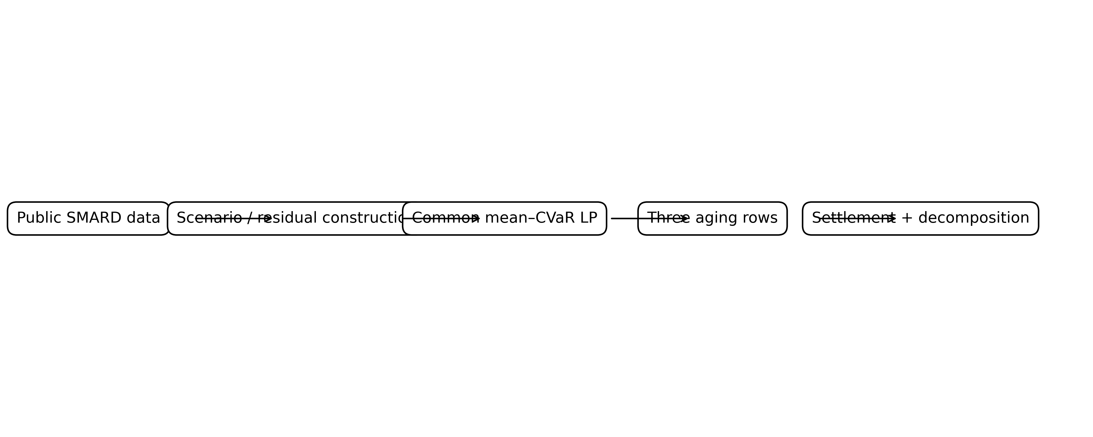
Interpretation: the figure shows the controlled identification structure used throughout the study. The three aging laws receive the same market, scenario, plant, and risk inputs; therefore differences in the resulting bid can be attributed to the aging representation rather than to a change in the surrounding optimization environment.
Figure 1 provides the experimental logic rather than an additional numerical result. Its purpose is to make the source of identification transparent: a common market model feeds three aging representations, and the downstream decomposition determines whether any profit difference arises from direct aging cost or from a changed market position.
VI. RESULTS
TABLE IV. ISOLATION-DAY RESULTS, K = 30
Day | Law | B2 | P1 | P1−B2 (EUR)
20 Jan | Throughput / Xu / ReLCCA | 10,330 / 10,332 / 9,886 | 11,260 / 11,258 / 11,100 | +930 / +926 / +1,214
5 Apr | Throughput / Xu / ReLCCA | 15,475 / 15,475 / 15,215 | 16,676 / 16,676 / 16,603 | +1,201 / +1,201 / +1,389
1 May | Throughput / Xu / ReLCCA | 14,492 / 14,492 / 13,180 | 14,246 / 14,225 / 13,696 | −246 / −266 / +515
19 Aug | Throughput / Xu / ReLCCA | 10,961 / 10,961 / 10,766 | 12,268 / 12,268 / 12,245 | +1,307 / +1,306 / +1,480
Table IV shows that ordinary days do not produce a systematic ranking advantage for ReLCCA. On 20 January, 5 April, and 19 August, reserve participation improves realized profit under all three aging laws. The differences between throughput and Xu are small on these days, while ReLCCA can produce a somewhat larger reserve-versus-energy differential without changing the qualitative sign.
TABLE V. CONTROLLED NEGATIVE-TROUGH INJECTION ON 19 AUGUST, K = 20
Injected minimum (EUR/MWh) | −50 | −80 | −200 | −300 | −414 | −499
Throughput P1−B2 | +1,145 | +1,051 | +878 | +836 | +804 | +790
ReLCCA P1−B2 | +1,353 | +1,306 | +1,189 | +1,141 | +1,092 | +1,056
Table V is a falsification-style control. Increasing the severity of the negative trough while keeping the 19 August residual structure does not create a ranking reversal. The throughput differential remains positive and the ReLCCA differential remains positive. Therefore, the existence of a negative price, by itself, is not sufficient to reproduce the 1 May mechanism.
FIG. 2. CONTROLLED NEGATIVE-PRICE TROUGH RESPONSE
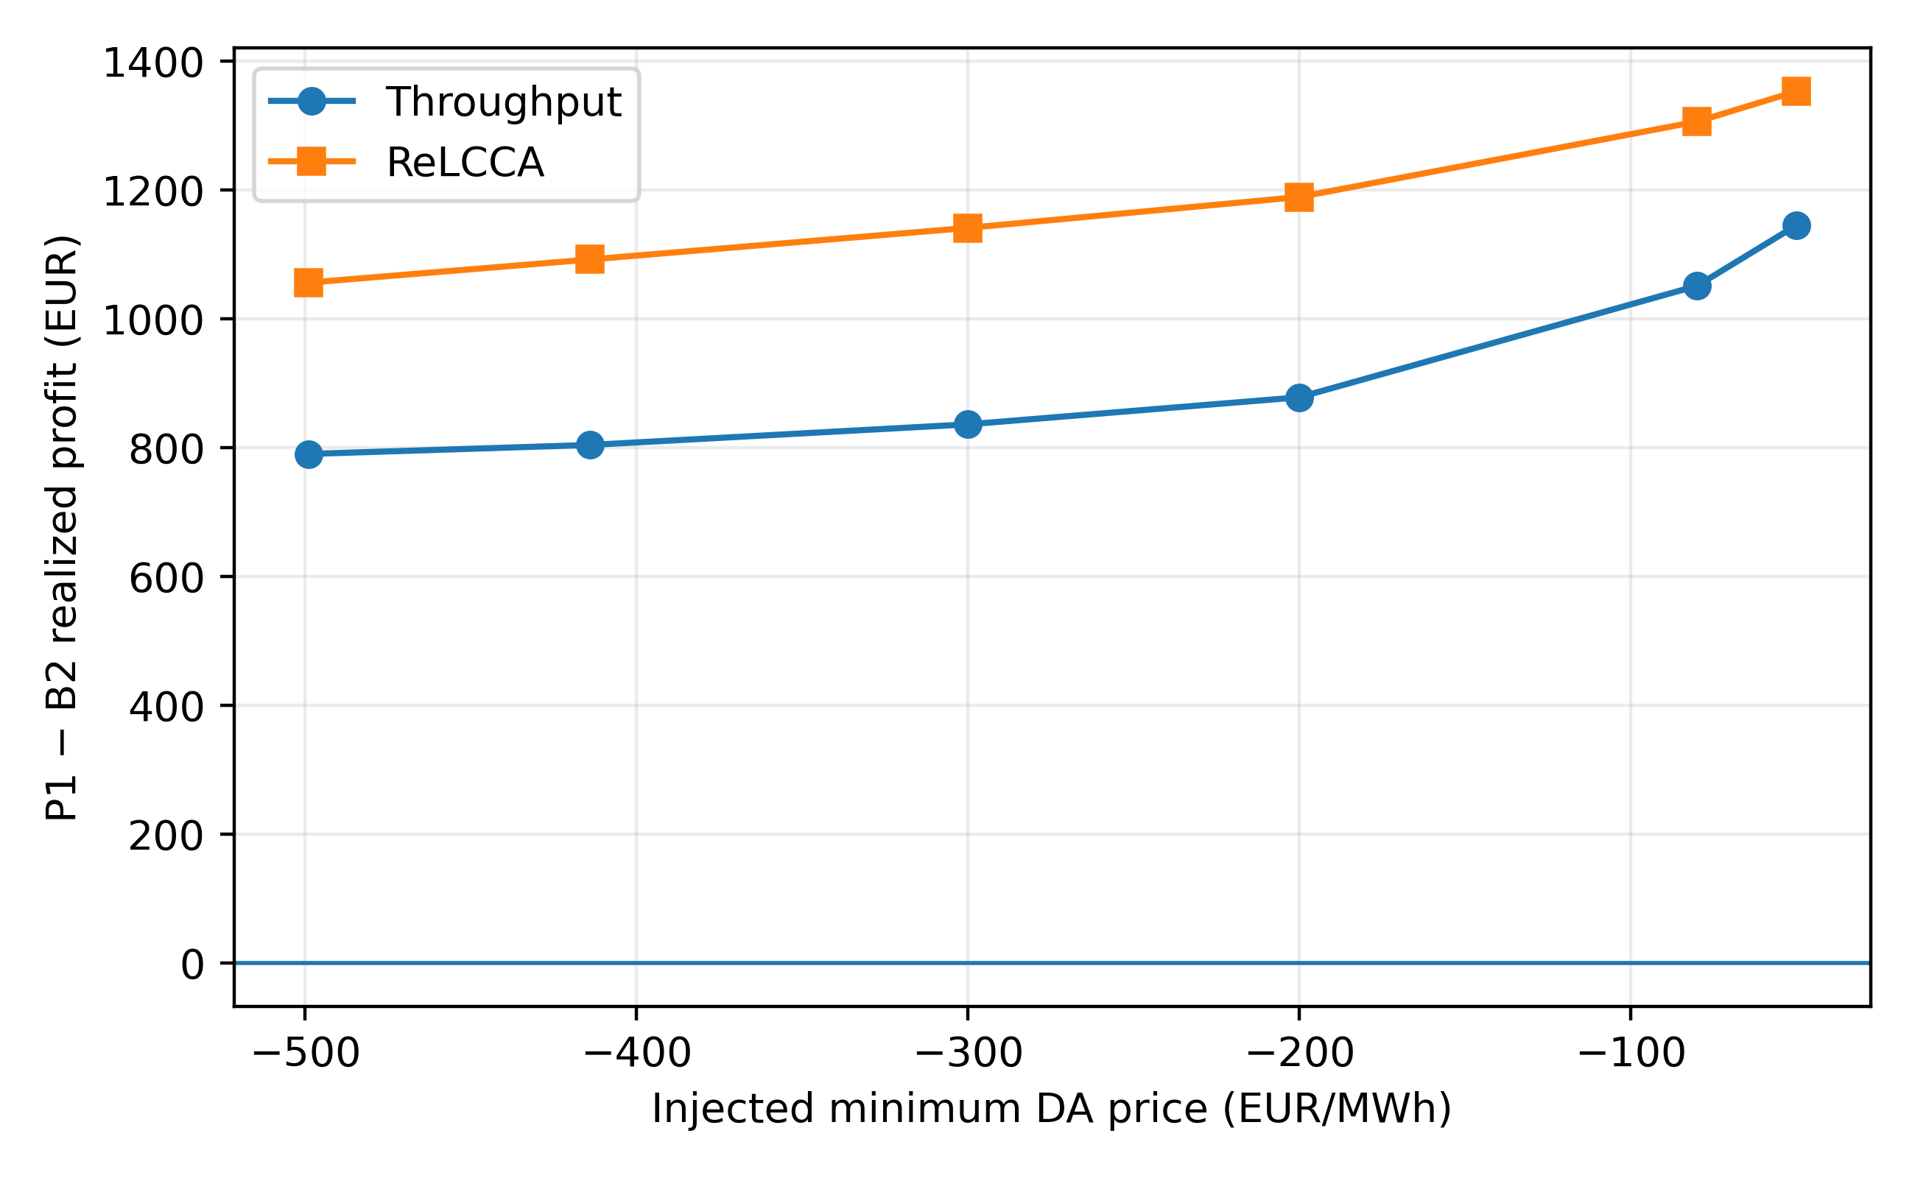
Interpretation: the intervention varies only the depth of the injected midday price trough while preserving the residual portfolio structure. The figure is therefore a controlled mechanism test, not a forecast of market prices.
Figure 2 should be interpreted as a controlled intervention rather than a market forecast. The experiment changes only the selected midday price path and therefore tests whether price-trough depth is sufficient to generate the observed sign change.
TABLE VI. 1 MAY WHOLESALE DECOMPOSITION, K = 30, EUR
Model | DA energy | aFRR | Imbalance | DG | Aging | Wholesale
B2-throughput | +978 | 0 | +600 | −1,714 | −58 | −194
P1-throughput | −541 | +1,333 | +436 | −1,635 | −32 | −440
B2-ReLCCA | −268 | 0 | +462 | −1,647 | −54 | −1,506
P1-ReLCCA | −1,238 | +1,457 | +474 | −1,635 | −49 | −991
Table VI is the central diagnostic result. Comparing the two energy-only books, B2-throughput earns +978 EUR from its day-ahead position whereas B2-ReLCCA records −268 EUR, a 1,246 EUR difference. The corresponding direct aging costs differ by only 4 EUR between those two rows (−58 versus −54 EUR). Comparing reserve books, the ReLCCA reserve cases receive 1,457 EUR versus 1,333 EUR in the corresponding throughput case, but that additional reserve income does not erase the energy-position effect. Thus the 1,312 EUR gap between the two energy-only books is primarily a bidding-position effect, not a direct aging-bill effect.
TABLE VII. NEGATIVE-PRICE SCAN: DAYS WITH MINIMUM DA PRICE BELOW −50 EUR/MWH
Day | Minimum | Throughput P1−B2 | Xu P1−B2 | ReLCCA P1−B2
1 May | −499 | −246 | −251 | +531
26 Apr | −414 | +139 | +137 | +869
25 Apr | −191 | +812 | +850 | +1,114
2 May | −130 | +887 | +887 | +1,188
6 Apr | −126 | +1,043 | +1,043 | +1,382
5 Apr | −105 | +1,182 | +1,182 | +1,381
11 Apr | −80 | +1,100 | +1,100 | +1,246
24 May | −76 | +1,115 | +1,115 | +1,316
29 Apr | −60 | +1,074 | +1,060 | +1,273
The scan covers all 20 days with minimum day-ahead price below −20 EUR/MWh; Table VII lists the nine days below −50 EUR/MWh. Throughput is negative only on 1 May. ReLCCA remains positive on all 20 qualifying days. The correct interpretation is therefore conditional: the observed reversal is a rare event in this study window, not evidence for a universal negative-price threshold.
FIG. 3. 1 MAY WHOLESALE PROFIT DECOMPOSITION
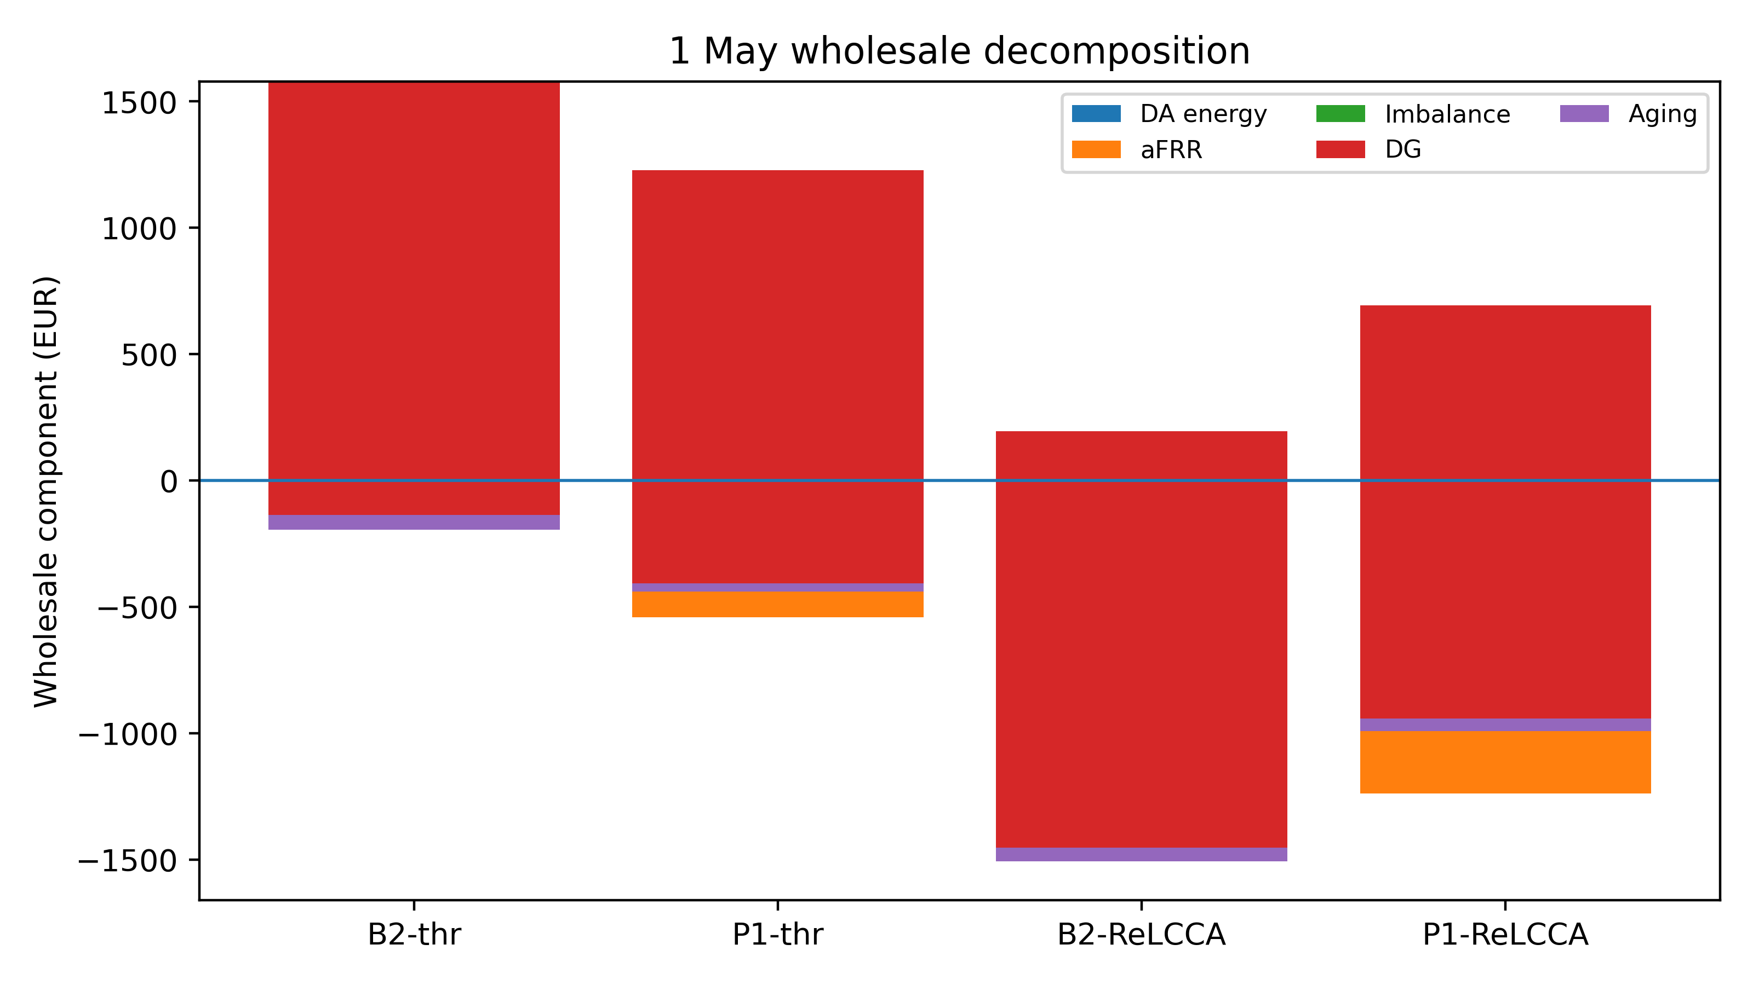
Interpretation: the decomposition separates the economic effect of the optimized day-ahead position from reserve, imbalance, DG, and direct aging components. The large difference between the energy-only cases is consequently attributable primarily to changed DA positioning rather than to a large direct aging charge.
Figure 3 is the visual counterpart of Table VI. Its purpose is attribution: readers can distinguish revenue/cost components that arise because the optimized market position changes from components directly produced by the aging law.
TABLE VIII. ROBUSTNESS AND SENSITIVITY CHECKS ON 1 MAY
Check | ReLCCA P1−B2 (EUR)
N = 4 / 6 / 8 / 12, K = 20 | +565 / +533 / +576 / +561
κ step / all-mid / all-high / 100% top, K = 30 | +515 / +514 / +512 / +515
Calendar only / cycle only / both, K = 30 | +587 / +512 / +515
K = 20 / K = 30 | +576 / +515
√t annualisation (κ × 0.913) | +516
Imbalance |DA| clipped at 150 | +541 (throughput −232)
rmax = 0.5 / 2.5 MW, K = 20 | +234 / +800 (throughput −91 / −262)
Eb = 2 MWh, K = 20 | +409 (throughput +19)
Table VIII shows that the positive ReLCCA differential persists across band counts, alternative calendar coefficients, calendar-only and cycle-only ablations, scenario counts, annualization treatment, imbalance clipping, reserve caps, and battery-energy capacity. The robustness result should not be interpreted as validation of the underlying κ values; rather, it demonstrates that the sign of the reported 1 May diagnostic is not sensitive to the tested modeling choices.
FIG. 4. RE LCCA BAND-COUNT ROBUSTNESS
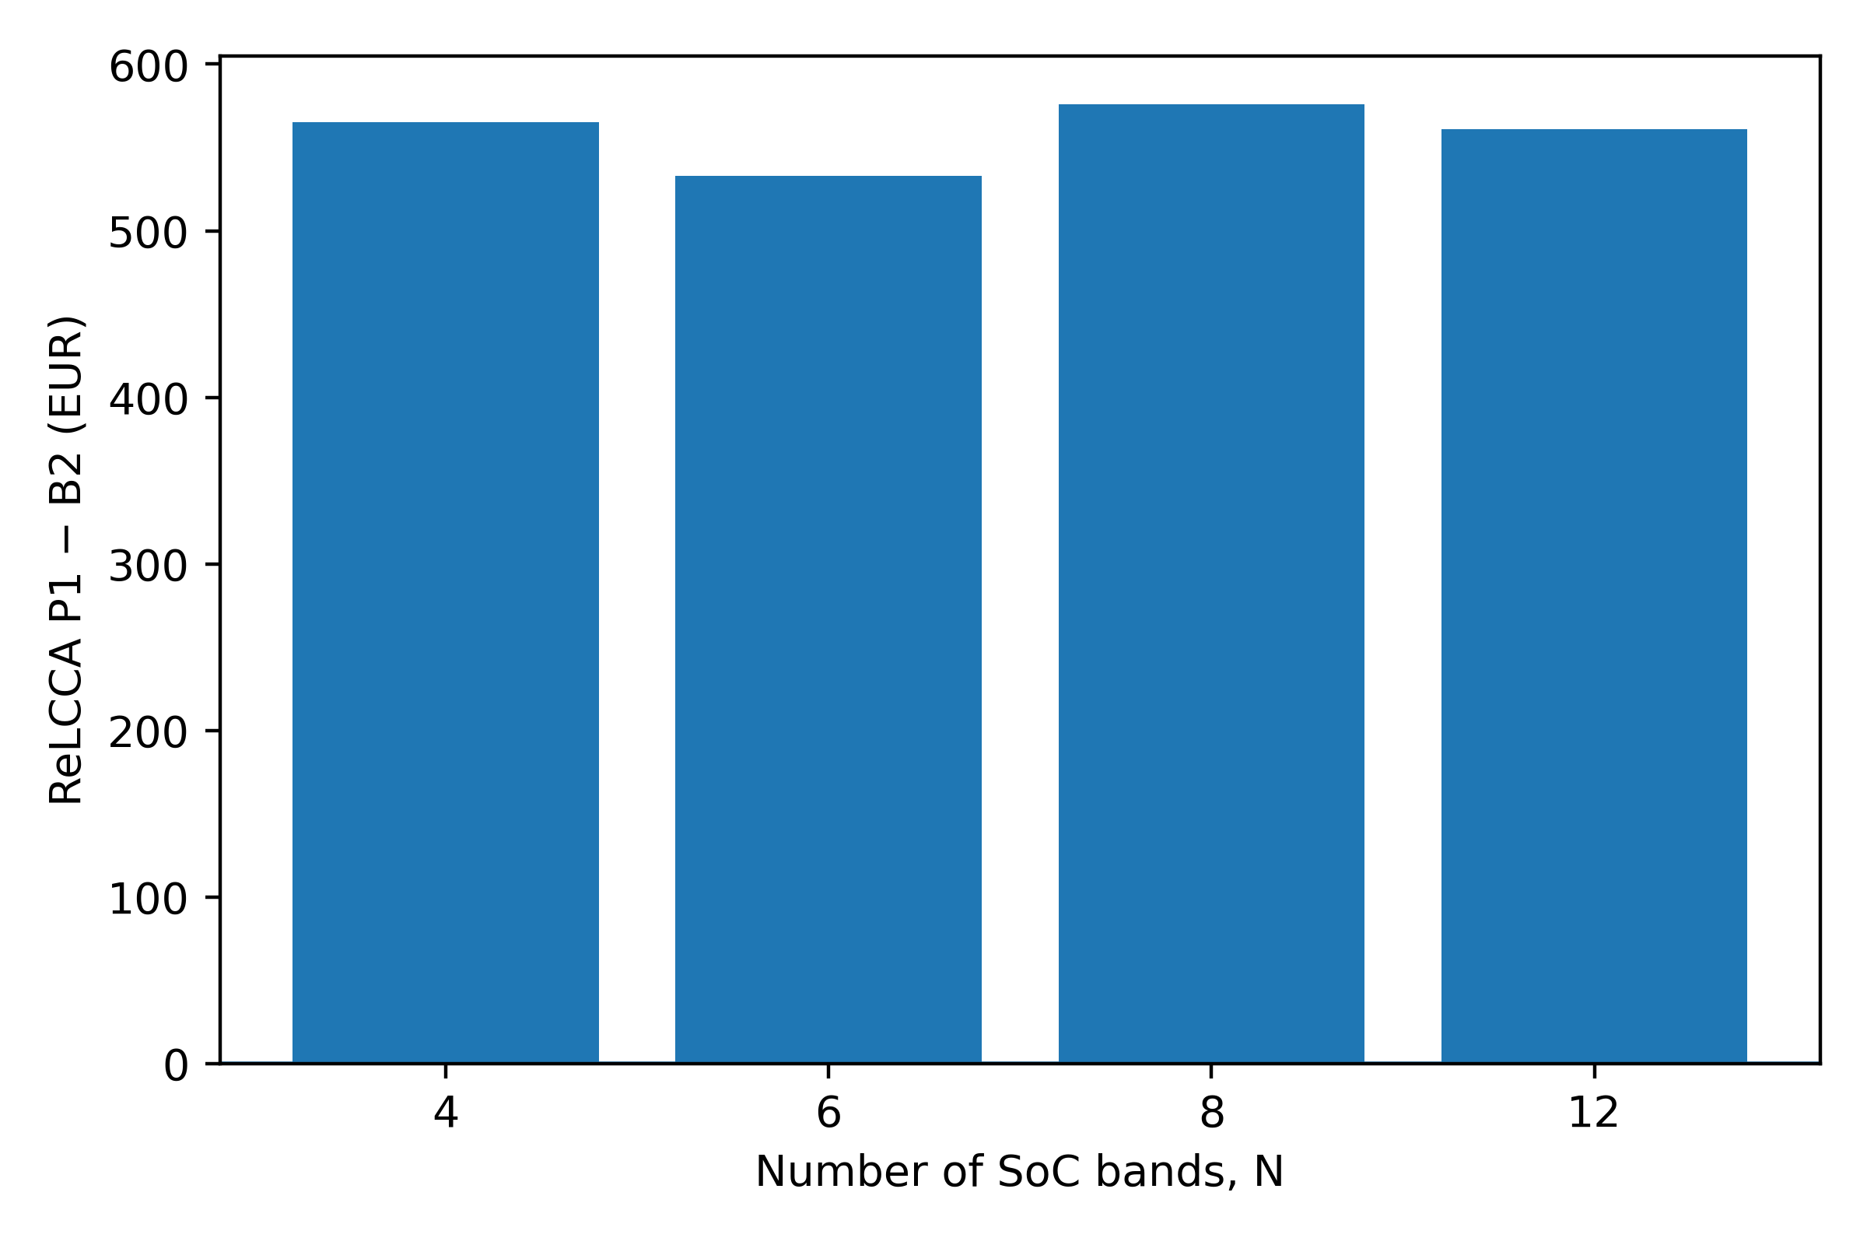
Interpretation: the figure tests numerical resolution by varying the number of SoC bands. Similar outcomes over the tested values support the structural interpretation of the 1 May diagnostic while not constituting electrochemical validation of the calendar-aging coefficients.
Figure 4 demonstrates numerical-resolution robustness. The absence of a monotonic trend with N is consistent with the interpretation that the result is structural within the tested discretization range rather than caused by selecting a single favorable band count.
VII. DISCUSSION
The results support a precise interpretation of calendar-aware degradation. On ordinary residuals, the additional occupancy cost does not necessarily change the qualitative value of reserve participation. Under the 1 May residual, however, the throughput energy-only solution becomes long during a severe negative-price interval. ReLCCA assigns an additional cost to maintaining high-energy occupancy and reserve parking, changing the optimal first-stage day-ahead position.
The decomposition is particularly important. It would be misleading to state that the bid reversal occurs because ReLCCA simply produces a much larger degradation bill. Table VI shows the opposite: the direct aging-cost difference between the two energy-only cases is only a few euros, while the day-ahead energy-position difference is 1,246 EUR. The aging representation acts as a shaping term inside the optimization and changes the market position; the downstream financial effect is therefore much larger than the direct aging charge.
The controlled injection reinforces this interpretation. A negative trough of −499 EUR/MWh imposed on an otherwise ordinary summer residual does not produce the same reversal. The residual portfolio state determines whether the energy-only model would exploit the trough by moving long. Hence the mechanism cannot be summarized as 'negative prices cause ReLCCA to outperform.' The defensible statement is that explicit occupancy pricing can alter the bid when the residual conditions make high-SoC positioning economically attractive under a sufficiently adverse price path.
The result also clarifies the role of reserve. The reserve product is not modeled as a detailed activation-energy settlement. Instead, upward reserve is coupled to parked energy through (15), and the published block-average capacity prices provide the capacity-revenue side. This is sufficient for the diagnostic question—whether reserve parking changes the economics of occupancy—but not sufficient for claiming day-specific aFRR settlement accuracy.
VIII. LIMITATIONS AND REPRODUCIBILITY
Several limitations bound the claims. First, the diagnosed event occurs once in 262 complete days, and September–November are absent from the study panel. The frequency of such events therefore cannot be estimated reliably from this sample. Second, ReLCCA is a linear market encoding of published NMC calendar/cycle-aging relationships rather than a cell-level electrochemical model. The three-plateau κ map is an operational parameterization, not an independently validated laboratory fit. Third, the linear annualization used in the baseline does not reproduce the exact square-root time dependence of calendar aging; the reported √t sensitivity is therefore a robustness test rather than a replacement electrochemical model.
Fourth, aFRR capacity prices are repeated four-hour block means rather than day-specific cleared auction records. Fifth, imbalance prices are a documented two-price proxy rather than directly observed reBAP settlements. Sixth, the model does not simulate the detailed activation-energy trajectory of aFRR. Seventh, the Xu benchmark is a daily-depth piecewise-linear model and is not equivalent to a rainflow implementation. Finally, the study uses a price-taking market role and does not model strategic price-making or network constraints.
The computational package uses Python/Pyomo with HiGHS. All reported optimization programs use the stated seed and common input data. The study should therefore be reproduced from the preserved project data and configuration rather than from manually transcribed numerical tables.
IX. CONCLUSION
This paper presented a controlled diagnostic for identifying when explicit calendar-aging exposure can change a risk-aware BESS energy–reserve bid. Three aging laws were embedded in one linear mean–CVaR market formulation, with ReLCCA extending cycle-aware operation by pricing SoC occupancy and reserve parking. On ordinary days, the three laws largely agree in the qualitative value of reserve participation. On 1 May 2026, however, the throughput energy-only solution becomes long in a −499 EUR/MWh midday trough while ReLCCA remains short. The wholesale decomposition shows that the associated 1,312 EUR difference between energy-only books is dominated by the day-ahead position rather than by the direct aging bill.
The controlled trough experiment and 20-day negative-price scan show why the result should be interpreted as a mechanism diagnosis rather than a universal threshold. Negative prices alone do not reproduce the reversal; the residual portfolio state must also make the energy-only position sufficiently exposed to the trough. The principal methodological contribution is therefore the diagnostic separation of physical aging cost from the market-position response induced by the aging model. Future work should replace reserve and imbalance proxies with day-specific German settlement data, extend the sample to a complete calendar year, and validate the occupancy-aging coefficients against measured cell or BESS field data.
ACKNOWLEDGMENT
Public German market and physical series are attributed to Bundesnetzagentur/SMARD and Fraunhofer ISE Energy-Charts. Reserve market context is based on the cited German aFRR market-data sources. Optimization is performed with the open-source HiGHS solver.
REFERENCES
[1] D. Pudjianto, C. Ramsay, and G. Strbac, “Virtual power plant and system integration of distributed energy resources,” IET Renewable Power Generation, vol. 1, no. 1, pp. 10–16, Mar. 2007.
[2] J. M. Morales, A. J. Conejo, and J. Pérez-Ruiz, “Short-term trading for a wind power producer,” IEEE Transactions on Power Systems, vol. 25, no. 1, pp. 554–564, Feb. 2010.
[3] A. J. Conejo, M. Carrión, and J. M. Morales, Decision Making Under Uncertainty in Electricity Markets. New York, NY, USA: Springer, 2010.
[4] H. Pandžić, I. Kuzle, and T. Capuder, “Virtual power plant mid-term dispatch optimization,” Applied Energy, vol. 101, pp. 134–141, Jan. 2013.
[5] M. Giuntoli and D. Poli, “Optimized thermal and electrical scheduling of a large scale virtual power plant in the presence of energy storages,” IEEE Transactions on Smart Grid, vol. 4, no. 2, pp. 942–955, Jun. 2013.
[6] E. G. Kardakos, C. K. Simoglou, and A. G. Bakirtzis, “Optimal offering strategy of a virtual power plant: A stochastic bi-level approach,” IEEE Transactions on Smart Grid, vol. 7, no. 2, pp. 794–806, Mar. 2016, doi: 10.1109/TSG.2015.2419714.
[7] L. Baringo and M. Rahimiyan, “Strategic bidding for a virtual power plant in the day-ahead and real-time markets: A price-taker robust optimization approach,” IEEE Transactions on Power Systems, vol. 31, no. 4, pp. 2676–2687, Jul. 2016.
[8] A. Baringo and L. Baringo, “A stochastic adaptive robust optimization approach for the offering strategy of a virtual power plant,” IEEE Transactions on Power Systems, vol. 32, no. 5, pp. 3492–3504, Sep. 2017, doi: 10.1109/TPWRS.2016.2633546.
[9] M. Vahedipour-Dahraie, H. Rashidizadeh-Kermani, M. Shafie-khah, and J. P. S. Catalão, “Risk-averse optimal energy and reserve scheduling for virtual power plants incorporating demand response programs,” IEEE Transactions on Smart Grid, vol. 12, no. 2, pp. 1405–1415, Mar. 2021.
[10] S. M. Nosratabadi, R.-A. Hooshmand, and E. Gholipour, “A comprehensive review on microgrid and virtual power plant concepts employed for distributed energy resources scheduling in power systems,” Renewable and Sustainable Energy Reviews, vol. 67, pp. 341–363, Jan. 2017, doi: 10.1016/j.rser.2016.09.025.
[11] M. M. Roozbehani, E. Heydarian-Forushani, S. Hasanzadeh, and S. E. E. Ben Elghali, “Virtual power plant operational strategies: Models, markets, optimization, challenges, and opportunities,” Sustainability, vol. 14, no. 19, art. 12486, 2022, doi: 10.3390/su141912486.
[12] H. Du, J. Hu, Y. Fang, and D. Xie, “Optimal bidding strategy for virtual power plant participating in joint energy and reserve market considering physical–economic feasible operation region,” Energy, vol. 336, art. 138410, 2025, doi: 10.1016/j.energy.2025.138410.
[13] P. Artzner, F. Delbaen, J.-M. Eber, and D. Heath, “Coherent measures of risk,” Mathematical Finance, vol. 9, no. 3, pp. 203–228, Jul. 1999.
[14] R. T. Rockafellar and S. Uryasev, “Optimization of conditional value-at-risk,” Journal of Risk, vol. 2, no. 3, pp. 21–41, 2000.
[15] R. T. Rockafellar and S. Uryasev, “Conditional value-at-risk for general loss distributions,” Journal of Banking & Finance, vol. 26, no. 7, pp. 1443–1471, Jul. 2002.
[16] R. Sioshansi, P. Denholm, T. Jenkin, and J. Weiss, “Estimating the value of electricity storage in PJM: Arbitrage and some welfare effects,” Energy Policy, vol. 37, no. 3, pp. 3085–3094, 2009.
[17] Y. Dvorkin, R. Fernández-Blanco, D. S. Kirschen, H. Pandžić, J.-P. Watson, and C. A. Silva-Monroy, “Ensuring profitability of energy storage,” IEEE Transactions on Power Systems, vol. 32, no. 1, pp. 611–623, Jan. 2017, doi: 10.1109/TPWRS.2016.2563259.
[18] H. C. Hesse, V. Kumtepeli, M. Schimpe, J. M. Reniers, D. A. Howey, A. Tripathi, Y. Wang, and A. Jossen, “Ageing and efficiency aware battery dispatch for arbitrage markets using mixed integer linear programming,” Energies, vol. 12, no. 6, art. 999, 2019, doi: 10.3390/en12060999.
[19] N. Collath, B. Tepe, S. Englberger, A. Jossen, and H. C. Hesse, “Aging aware operation of lithium-ion battery energy storage systems: A review,” Journal of Energy Storage, vol. 55, art. 105634, Nov. 2022, doi: 10.1016/j.est.2022.105634.
[20] D. Krishnamurthy, C. Uçkun, Z. Zhou, P. Thimmapuram, and A. Botterud, “Energy storage arbitrage under day-ahead and real-time price uncertainty,” IEEE Transactions on Power Systems, vol. 33, no. 1, pp. 84–93, Jan. 2018, doi: 10.1109/TPWRS.2017.2685347.
[21] J. Vetter et al., “Ageing mechanisms in lithium-ion batteries,” Journal of Power Sources, vol. 147, no. 1–2, pp. 269–281, Sep. 2005.
[22] M. Broussely et al., “Main aging mechanisms in Li ion batteries,” Journal of Power Sources, vol. 146, no. 1–2, pp. 90–96, Aug. 2005.
[23] A. Barré, B. Deguilhem, S. Grolleau, M. Gérard, F. Suard, and D. Riu, “A review on lithium-ion battery ageing mechanisms and estimations for automotive applications,” Journal of Power Sources, vol. 241, pp. 680–689, Nov. 2013.
[24] P. Keil, S. F. Schuster, J. Wilhelm, J. Travi, A. Hauser, R. C. Karl, and A. Jossen, “Calendar aging of lithium-ion batteries,” Journal of The Electrochemical Society, vol. 163, no. 9, pp. A1872–A1880, 2016, doi: 10.1149/2.0411609jes.
[25] J. Schmalstieg, S. Käbitz, M. Ecker, and D. U. Sauer, “A holistic aging model for Li(NiMnCo)O2 based 18650 lithium-ion batteries,” Journal of Power Sources, vol. 257, pp. 325–334, Jul. 2014, doi: 10.1016/j.jpowsour.2014.02.012.
[26] M. Ecker et al., “Calendar and cycle life study of Li(NiMnCo)O2-based 18650 lithium-ion batteries,” Journal of Power Sources, vol. 215, pp. 248–257, 2012.
[27] B. Xu, J. Zhao, T. Zheng, E. Litvinov, and D. S. Kirschen, “Factoring the cycle aging cost of batteries participating in electricity markets,” IEEE Transactions on Power Systems, vol. 33, no. 2, pp. 2248–2257, Mar. 2018.
[28] B. Xu, A. Oudalov, A. Ulbig, G. Andersson, and D. S. Kirschen, “Modeling of lithium-ion battery degradation for cell life assessment,” IEEE Transactions on Smart Grid, vol. 9, no. 2, pp. 1131–1140, Mar. 2018, doi: 10.1109/TSG.2016.2578950.
[29] Y. Shi, B. Xu, Y. Tan, D. Kirschen, and B. Zhang, “Optimal battery control under cycle aging mechanisms in pay for performance settings,” IEEE Transactions on Automatic Control, vol. 64, no. 6, pp. 2328–2342, Jun. 2019.
[30] F. Wankmüller, P. R. Thimmapuram, K. G. Gallagher, and A. Botterud, “Impact of battery degradation on energy arbitrage revenue of grid-level energy storage,” Journal of Energy Storage, vol. 10, pp. 56–66, Apr. 2017.
[31] J. M. Reniers, G. Mulder, and D. A. Howey, “Review and performance comparison of mechanical-chemical degradation models for lithium-ion batteries,” Journal of The Electrochemical Society, vol. 166, no. 14, pp. A3189–A3200, 2019, doi: 10.1149/2.0281914jes.
[32] Q. Fan and D. Liu, “A Wasserstein-distance-based distributionally robust chance-constrained bidding model for virtual power plant considering electricity–carbon trading,” IET Renewable Power Generation, vol. 18, no. 3, 2024, doi: 10.1049/rpg2.12806.
[33] R. Gao and A. J. Kleywegt, “Distributionally robust stochastic optimization with Wasserstein distance,” Mathematics of Operations Research, vol. 48, no. 2, pp. 603–655, 2023, doi: 10.1287/moor.2022.1275.
[34] H. Heitsch and W. Römisch, “Scenario reduction algorithms in stochastic programming,” Computational Optimization and Applications, vol. 24, pp. 187–206, 2003.
[35] J.-F. Toubeau, J. Bottieau, Z. De Greeve, F. Vallée, and K. Bruninx, “Data-driven scheduling of energy storage in day-ahead energy and reserve markets with probabilistic guarantees on real-time delivery,” IEEE Transactions on Power Systems, vol. 36, no. 4, pp. 2815–2828, Jul. 2021, doi: 10.1109/TPWRS.2020.3046710.
[36] M. Merten, C. Olk, I. Schoeneberger, and D. U. Sauer, “Bidding strategy for battery storage systems in the secondary control reserve market,” Applied Energy, vol. 268, art. 114951, Jun. 2020, doi: 10.1016/j.apenergy.2020.114951.
[37] M. Merten, F. Rücker, I. Schoeneberger, and D. U. Sauer, “Automatic frequency restoration reserve market prediction: Methodology and comparison of various approaches,” Applied Energy, vol. 268, art. 114978, Jun. 2020, doi: 10.1016/j.apenergy.2020.114978.
[38] D. Fernández-Muñoz and J. I. Pérez-Díaz, “Optimisation models for the day-ahead energy and reserve self-scheduling of a hybrid wind–battery virtual power plant,” Journal of Energy Storage, vol. 57, art. 106296, Jan. 2023, doi: 10.1016/j.est.2022.106296.
[39] V. Kumtepeli, H. C. Hesse, M. Schimpe, A. Tripathi, Y. Wang, and A. Jossen, “Energy arbitrage optimization with battery storage: 3D-MILP for electro-thermal performance and semi-empirical aging models,” IEEE Access, vol. 8, pp. 204325–204341, 2020, doi: 10.1109/ACCESS.2020.3035504.
[40] M. Naumann, M. Schimpe, P. Keil, H. C. Hesse, and A. Jossen, “Analysis and modeling of calendar aging of a commercial LiFePO4/graphite cell,” Journal of Energy Storage, vol. 17, pp. 153–169, Jun. 2018, doi: 10.1016/j.est.2018.01.019.
[41] G. K. Petrin, S. Arens, P. Schoenfeld, P. Klement, and S. Schlüters, “Modeling battery aging in linear energy system optimizations by applying convex hulls – accuracy benefits and computational costs,” Applied Energy, vol. 399, art. 126492, 2025, doi: 10.1016/j.apenergy.2025.126492.
[42] E. Ghanaee, J. I. Pérez-Díaz, D. Fernández-Muñoz, J. Nájera, M. Chazarra, and S. Castaño-Solís, “Optimal scheduling of a hybrid wind–battery power plant in the day-ahead and reserve markets considering battery degradation cost,” in Proc. 2024 IEEE Int. Conf. on Smart Energy Systems and Technologies (SEST), 2024, doi: 10.1109/SEST61601.2024.10694289.
[43] A. Mujeeb, Z. Hu, J. Wang, R. Diao, L. Liu, and Z. Bao, “Optimizing virtual power plant operations in energy and frequency regulation reserve markets: A risk-averse two-stage scenario-oriented stochastic approach,” International Transactions on Electrical Energy Systems, 2025, art. 6640754, doi: 10.1155/etep/6640754.
[44] X. Wang, K. Lei, H. Wu, B. Xu, and J. Ding, “A conditional value-at-risk-based bidding strategy for PVSS participation in energy and frequency regulation ancillary markets,” Sustainability, vol. 18, no. 2, art. 1122, 2026, doi: 10.3390/su18021122.
[45] O. N. Onsomu, E. Terciyanlı, and B. Yeşilata, “Optimal dispatch of a virtual power plant considering distributed energy resources under uncertainty,” Energies, vol. 18, no. 15, art. 4012, 2025, doi: 10.3390/en18154012.
[46] Bundesnetzagentur, “SMARD – Strommarktdaten,” Bonn, Germany. [Online]. Available: https://www.smard.de.
[47] B. Burger, “Energy-Charts,” Fraunhofer Institute for Solar Energy Systems ISE, Freiburg, Germany. [Online]. Available: https://www.energy-charts.info.
[48] Modo Energy, “German aFRR market data explained,” Jul. 2026. [Online]. Available: https://modoenergy.com/research/en/germany-afrr-data-explained-ko-analysis.
[49] Pexapark, “High downward aFRR prices can drive additional income for solar assets in Germany,” Jan. 6, 2026. [Online]. Available: https://pexapark.com/blog/high-downward-afrr-prices-can-drive-additional-income-for-solar-assets-in-germany-pexapark-analysis.
[50] Q. Huangfu and J. A. J. Hall, “Parallelizing the dual revised simplex method,” Mathematical Programming Computation, vol. 10, pp. 119–142, 2018.

